October 26, 2018

Wenxin Gong

4452873

csse2002

assignment3

## DESIGN

This is the view of this application. Once user open this file, this window will be shown. This application is consisted by four main part, the top left is menu called file, where player can save or load map. The left middle is the canvas, which will show all the map, and it will change by player click any buttons. Also, the builder will stay the centre, so that user does not need to spend time on finding builder. The left bottom will show user what they have in their builder inventory. Finally, the right part contains all the buttons, so that users are allowed to move or change anything of this builder. At this moment, user has not loaded any file, so all of the buttons will be disable, and user cannot click it, including choose box and text field.

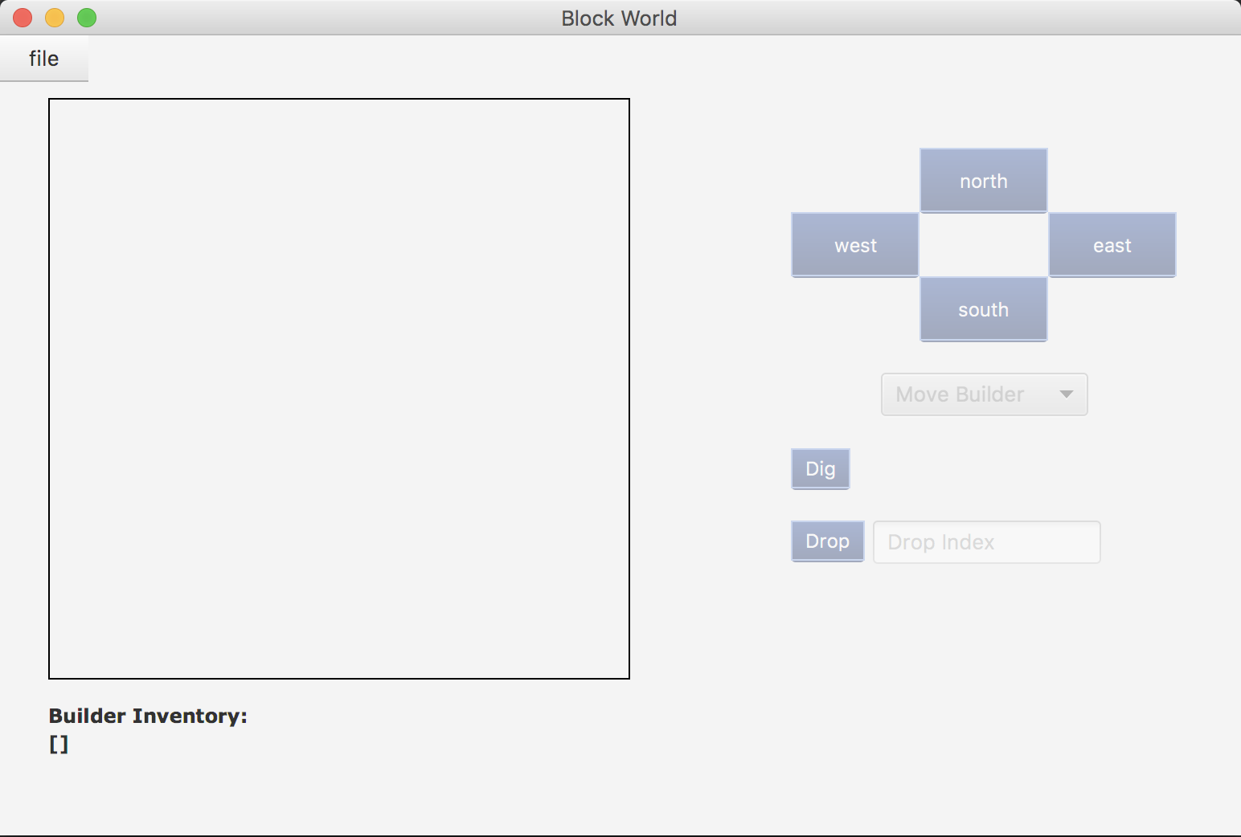

Considering builder may have lots of inventory, so that the inventory label will change to scroll pane once user have so much blocks, and it will change back to label after user drops some.

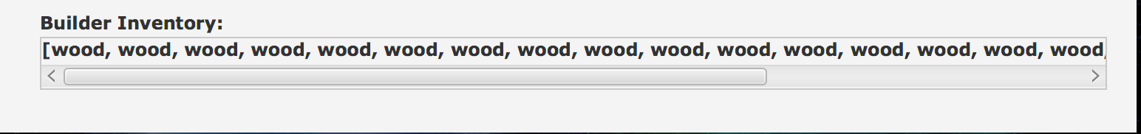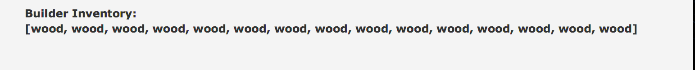

The blocks types are grass (green), stone (grey), soil (black) and wood (brown). And all of those blocks will be stroke by black line for user to see clearly. And the number if blocks of each tile will be shown as text. Also, the white triangle will be represented the exit, yellow cycle as builder. If there is no block it will be white, with exits if it has.

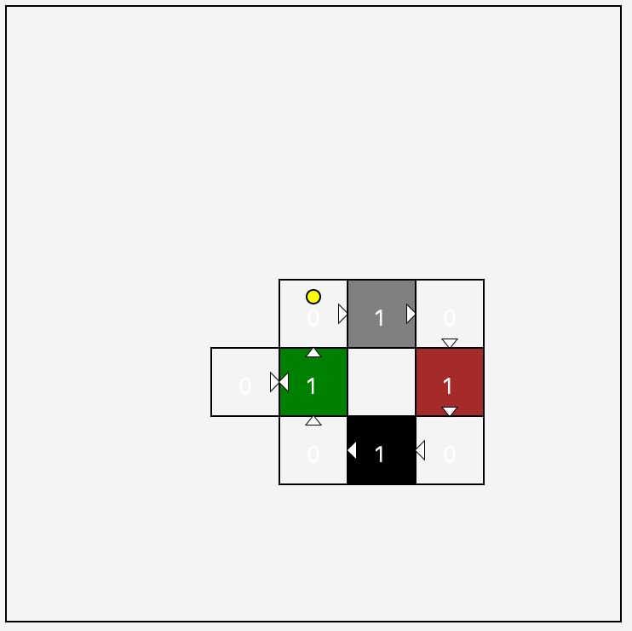

## Functionality

If user try to save map without load any map, there will be an alert window shown to reminder user that he has to load file first before save.

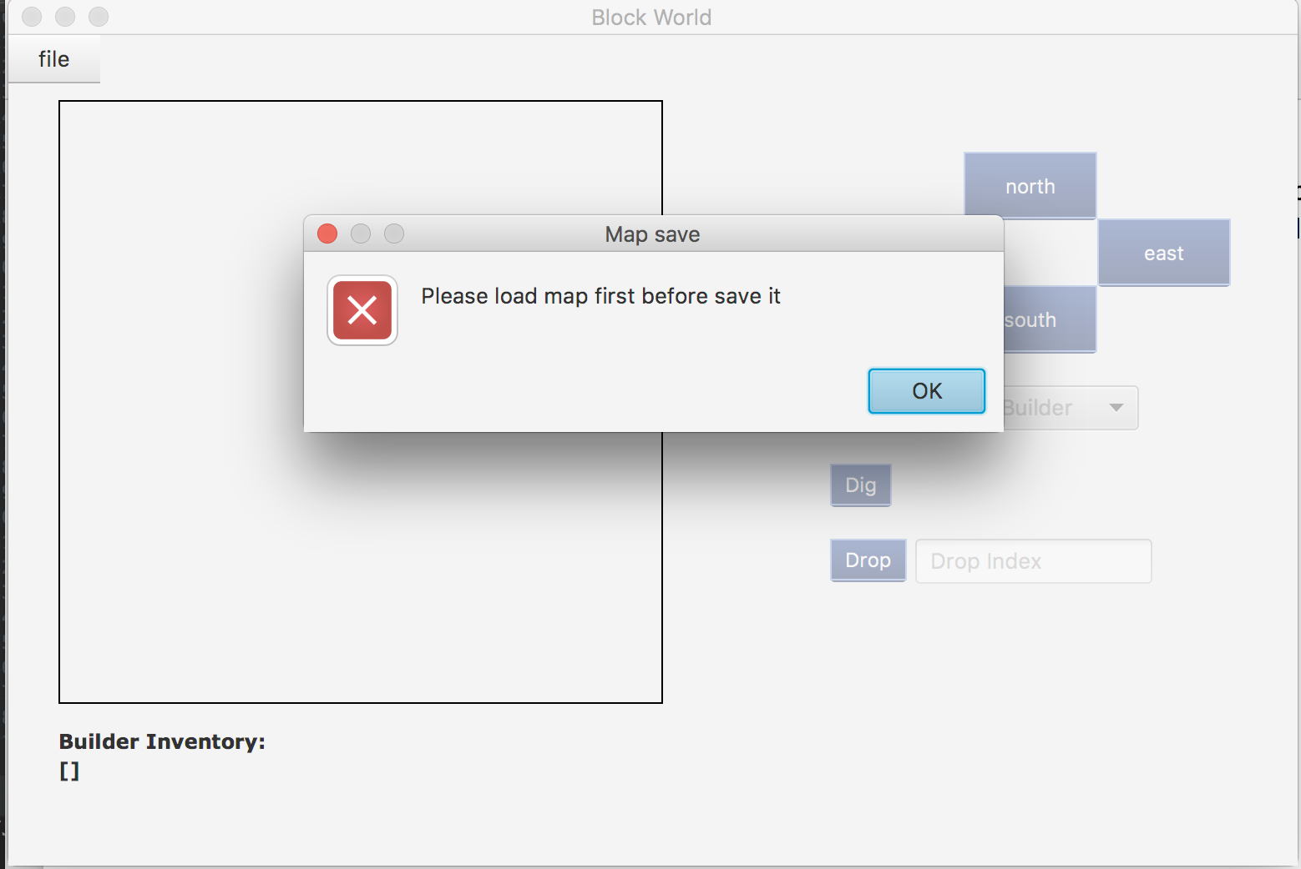

So that, the only thing user can do now is load file. Once they click on load button, the file chooser will be shown as follow.

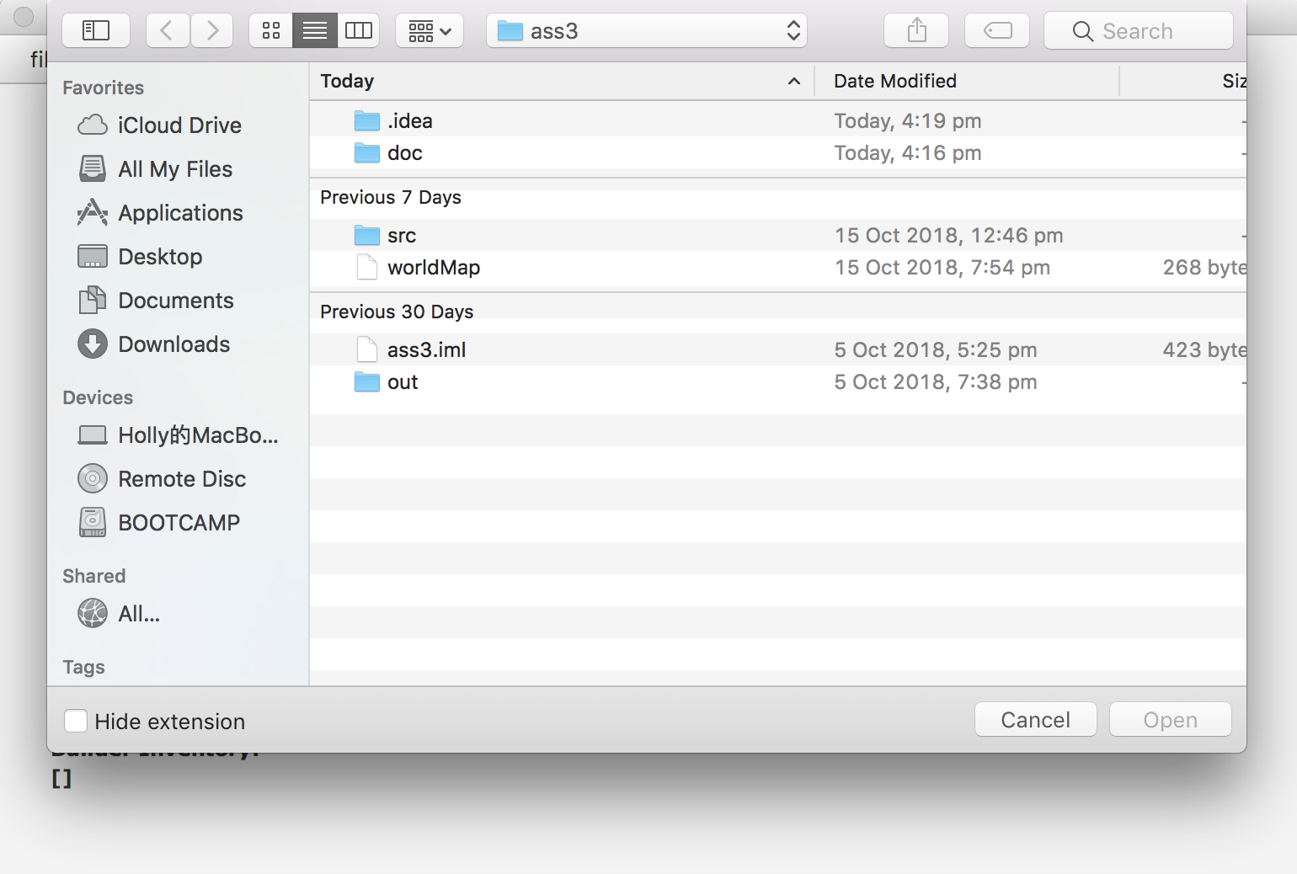

If user open wrong file, which cannot be loaded as world map. The alert window will be shown to reminder user that this file cannot be loaded.

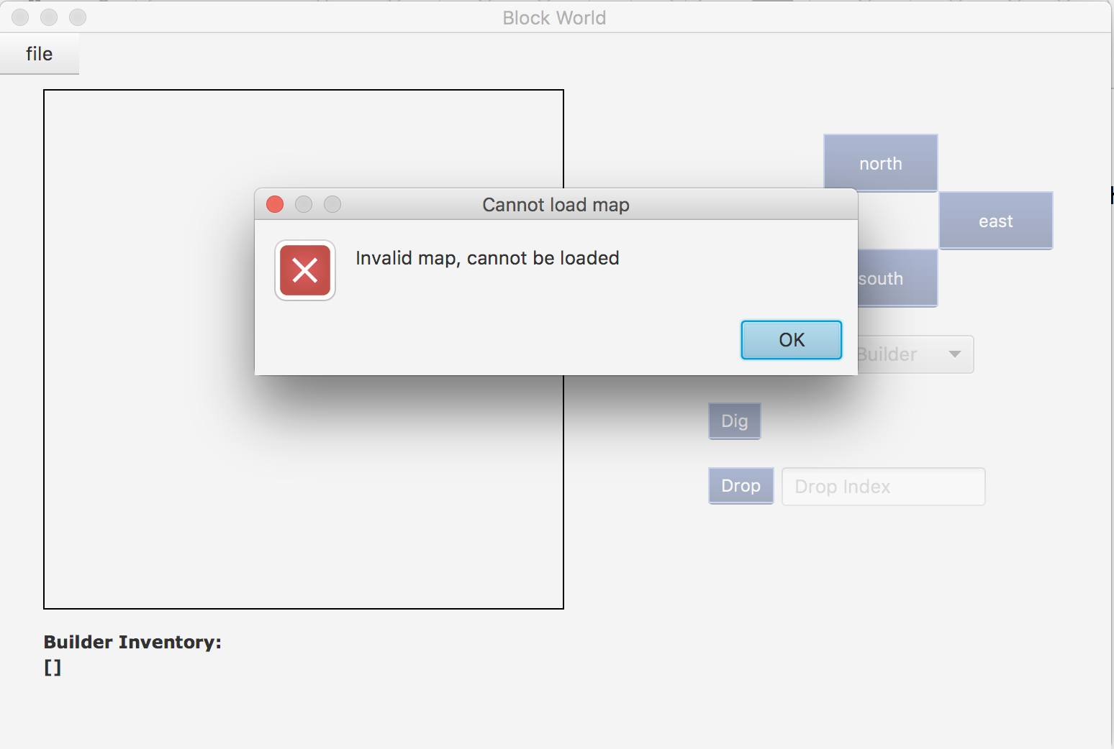

Once user chooses correct file, this map will be loaded automatically, and the canvas will show all the tiles, exits, block number, builder. And the builder inventory will add all builder’s block inside. Also, all the button will be set disable to false, which means users are able to click them. In addition, there will be an alert window to tell user that this map loads successfully.

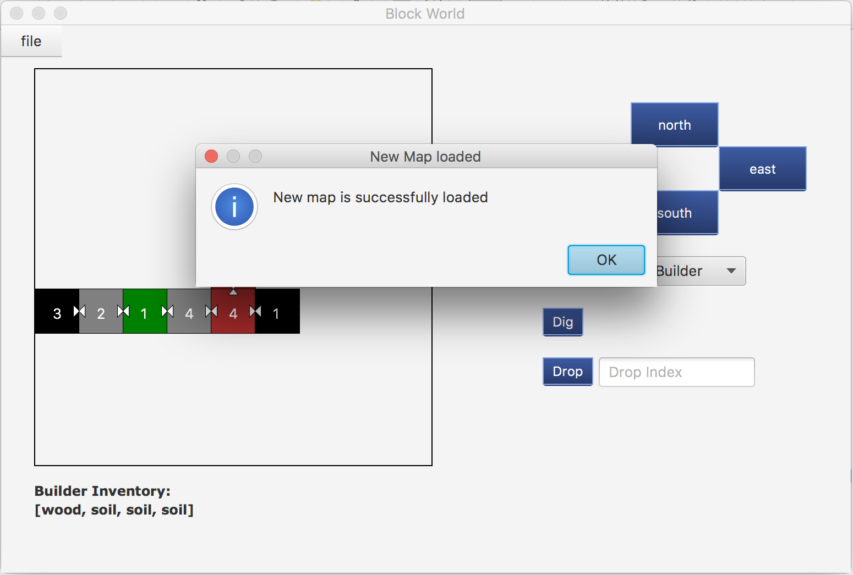

The yellow circle represents the builder, and the rectangles represent tiles. The number of each rectangle means the number of blocks of each tile. And there exits are represented as white triangle, which is drawn in this map.

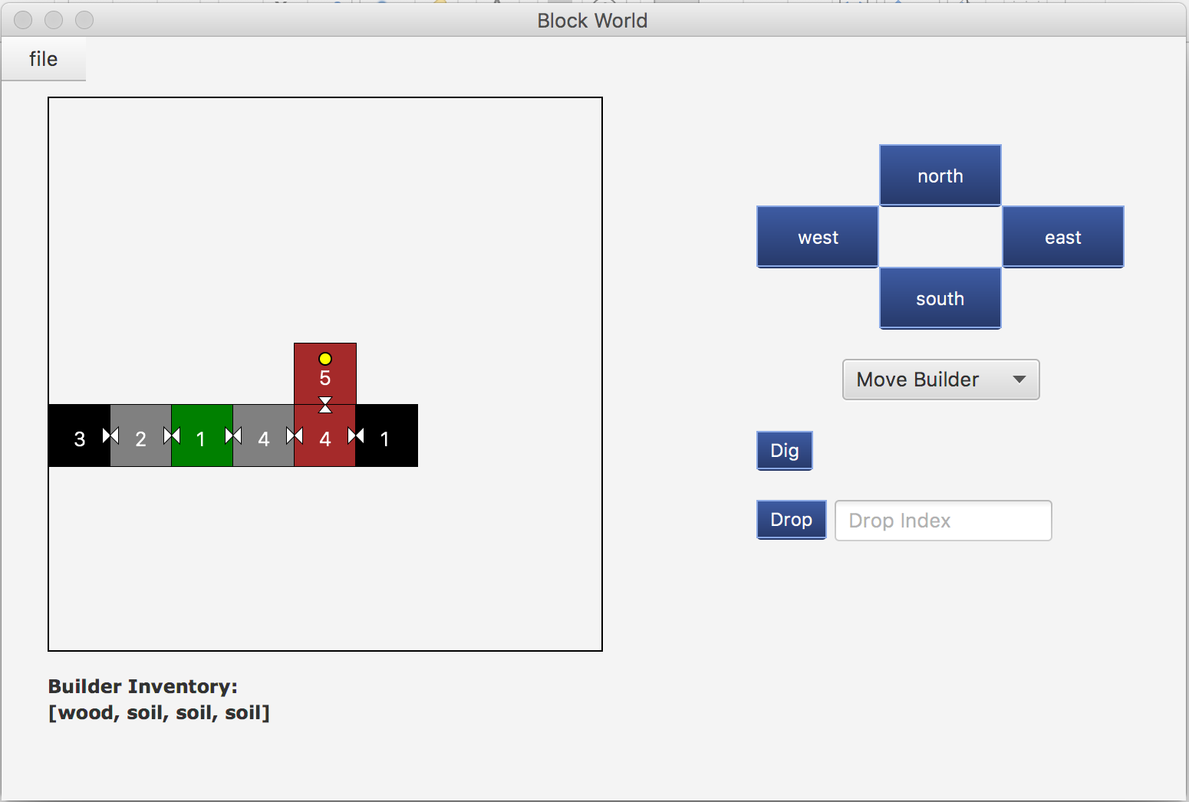

Basically, user can choose four different actions, that move builder, move block, dig block and drop block. To begin with, user can change the option of this combo box. They are able to choose “move builder” or “move block”. This combo box will be used with move buttons. And this combo box is as follow.

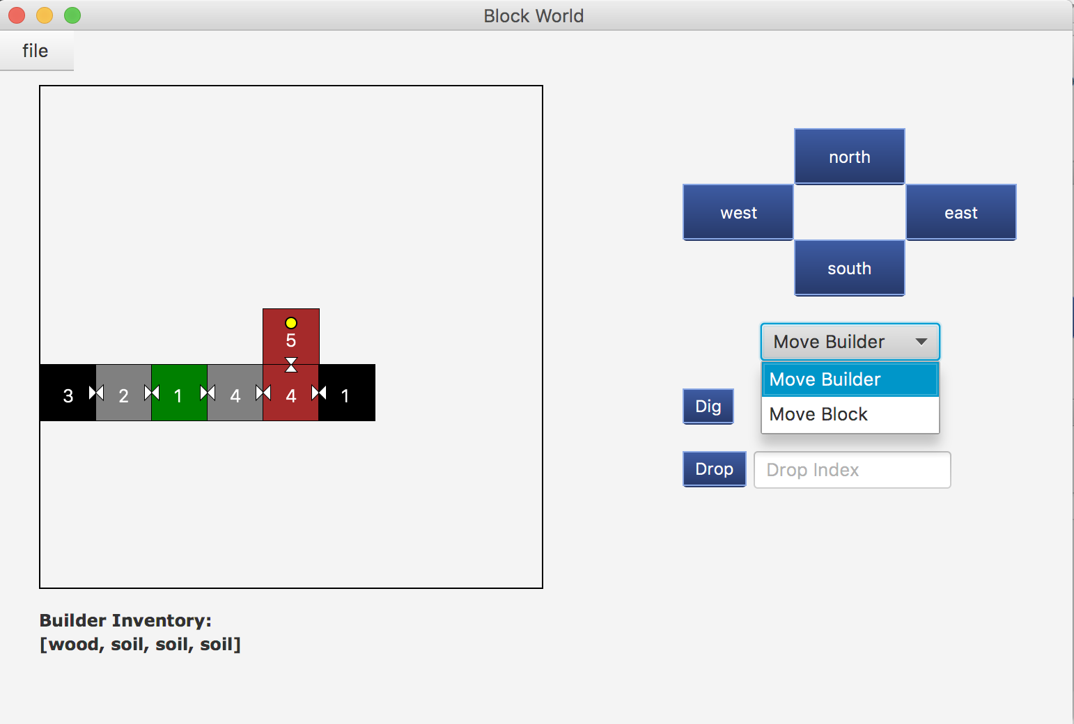

If player choose “Move Builder”, then they can change the position of this builder. If there is a target tile in that direction, the builder will be moved, and this map will be redrawn. However, the builder will not really be moved, these tiles will. It means that the builder will always be the centre of this canvas.

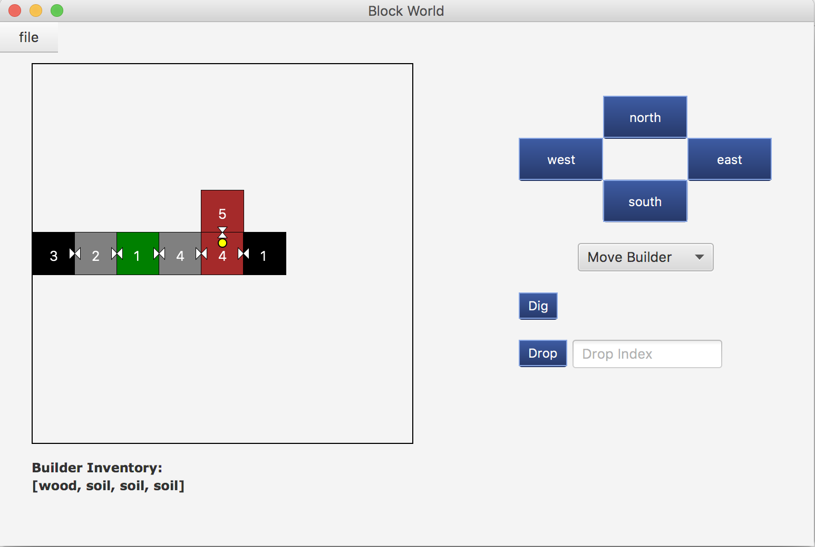

If builder’s current tile does not have an exit in one direction, but user still try to move builder to that way, the alert window will be shown to prevent user and remind it.

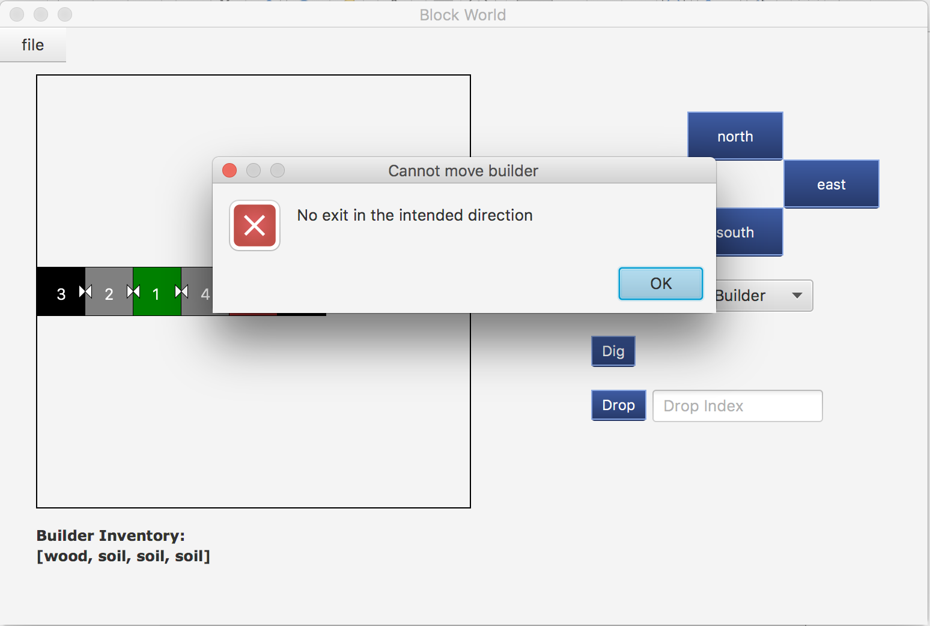

If this tile has that exit, but the target tile is too high to arrive, it will also show an alert window to remind user that the target tile is too high.

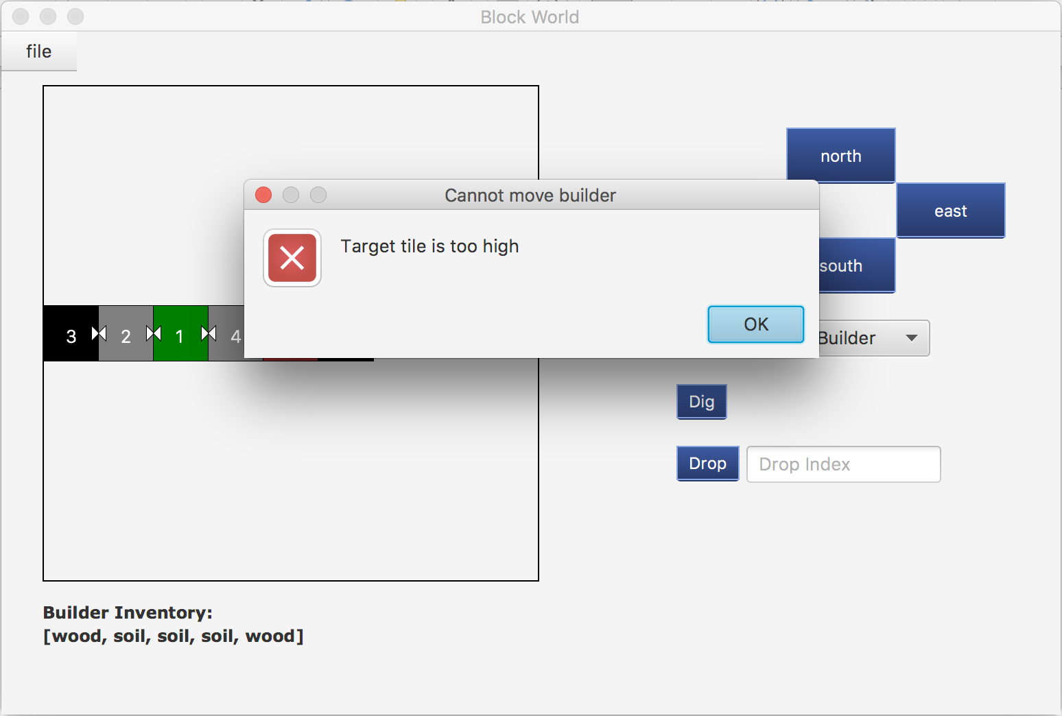

Also, if the target tile is too low to arrive, the alert window will remind user that the target tile is too low.

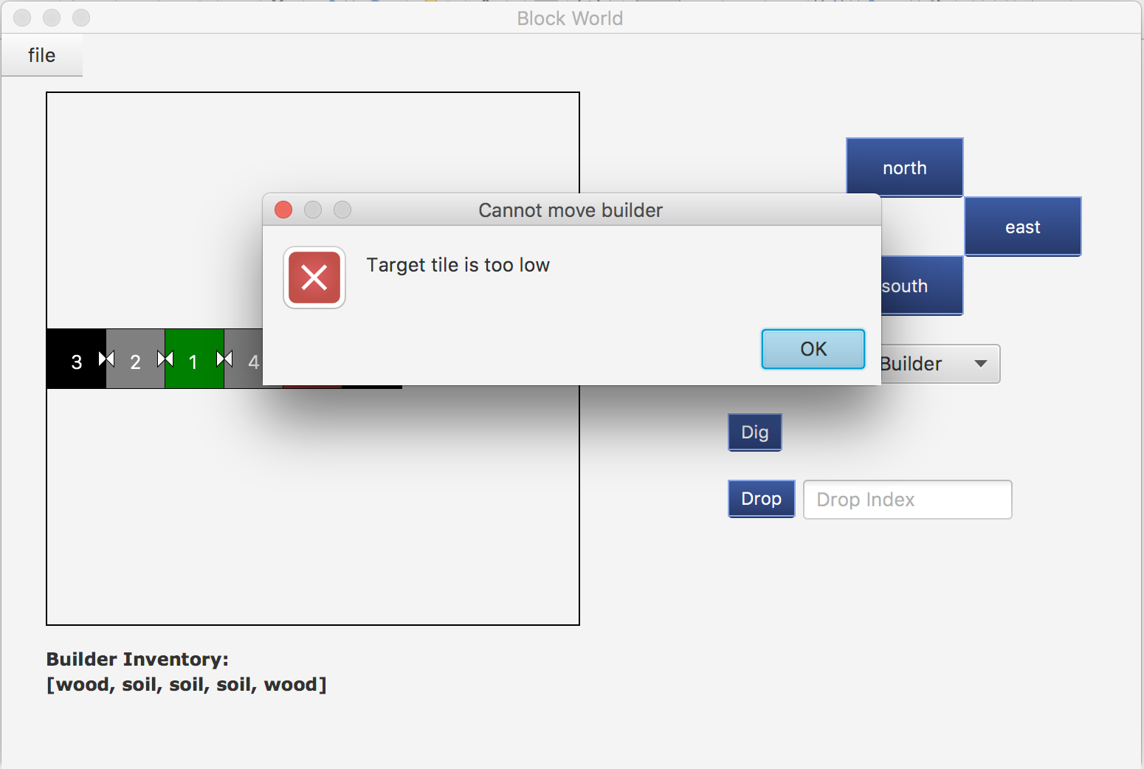

So that, builder is able to go through this map if the target tile is exist and is not too high or too low. Then, users can change the combo box to “move block”, if they want to move block to other way. (The left one is before user move block to east, the right one is after that action)

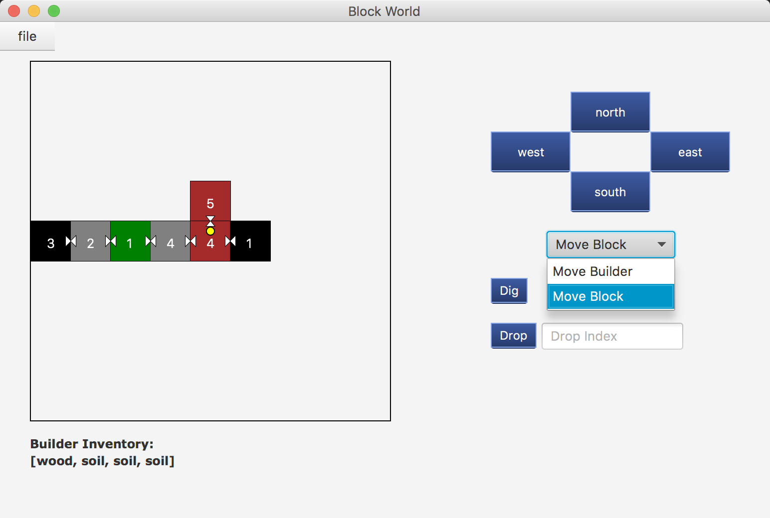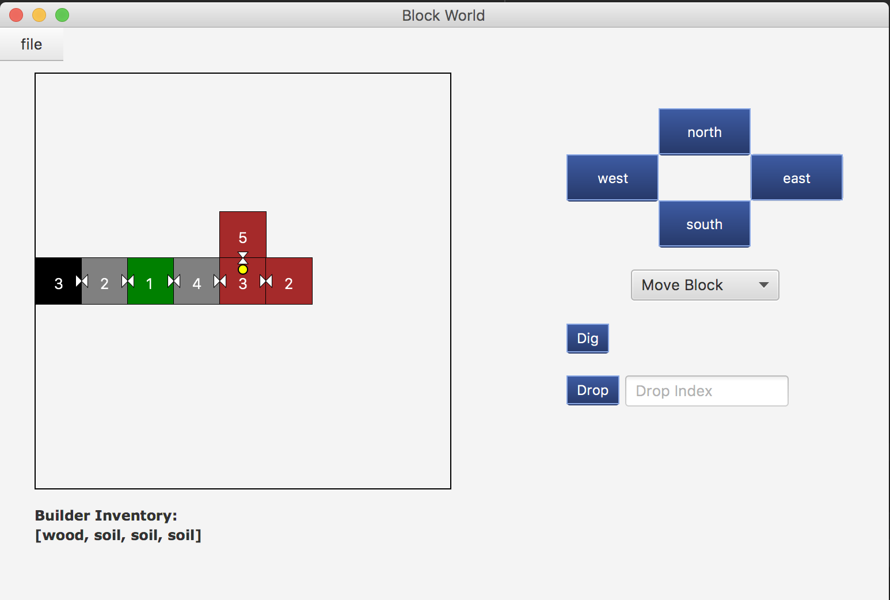

If the target tile is too high to place a block, then the alert window will be shown to remind user that the target tile is too high.

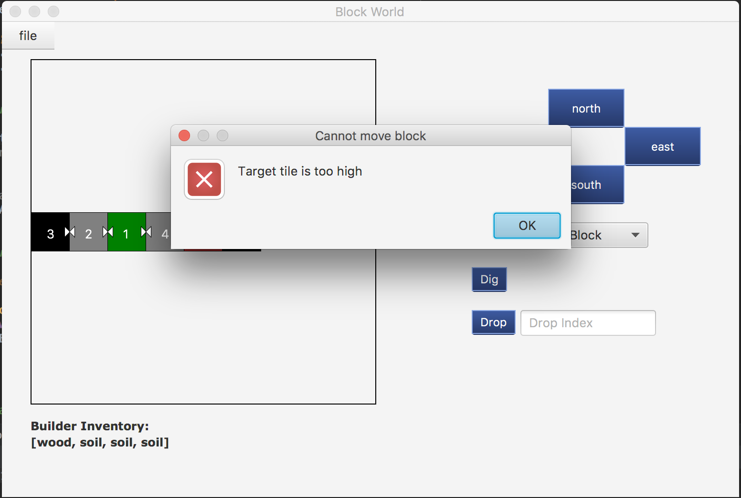

Besides, if the top block cannot be moved, the alert window will also be shown to remind player that the top block is not movable.

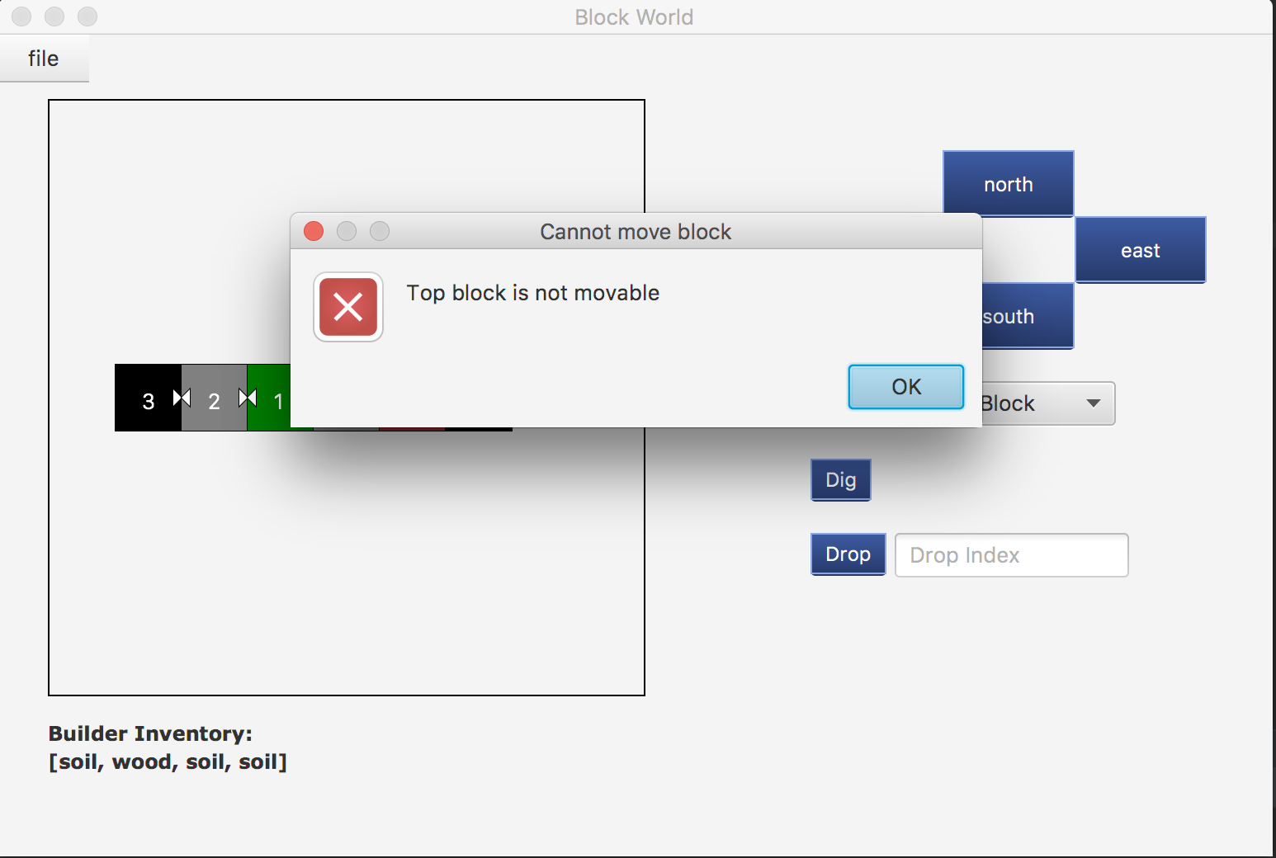

Also, user can use dig to dig the top block of the current tile, and the colour of current tile will be changed by the current top block. The number of blocks will also be changed. And this block will be added in the builder inventory, which will be printed in the inventory label. (the left one is before dig, the right one is after dig)

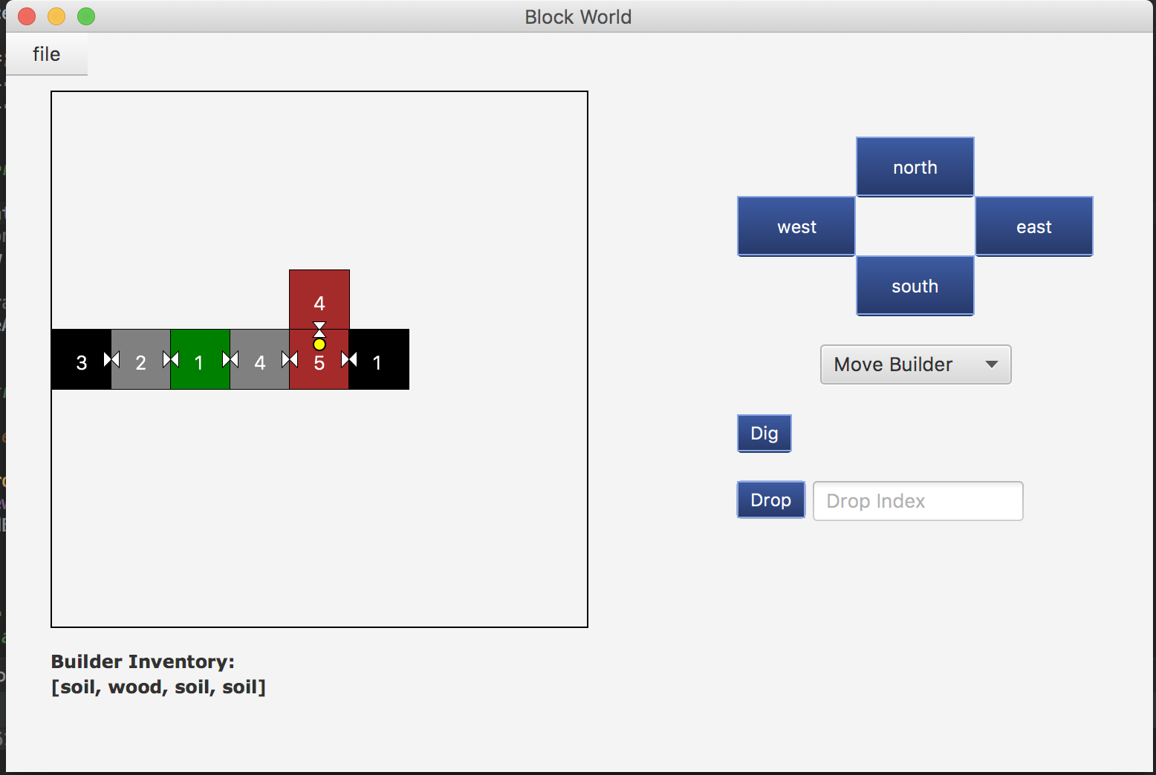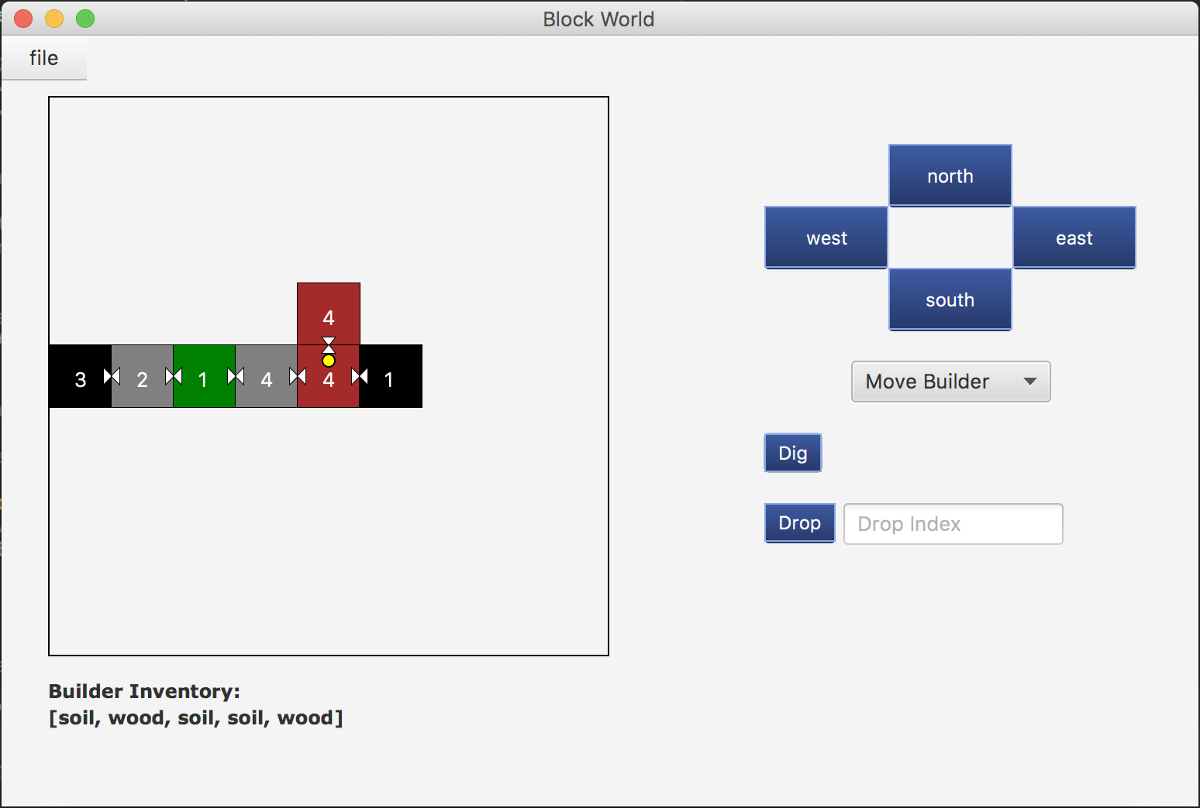

If the top block of player’s inventory is not diggable, the alert box will be shown and remind user.

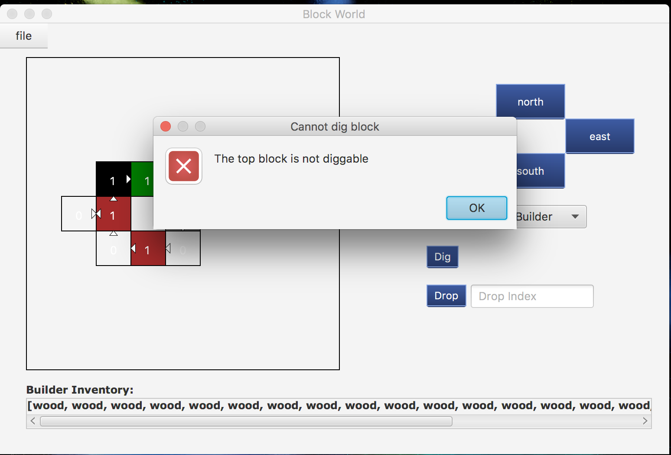

Also, if user still try to dig block, but the current tile does not have any block, user will also be noticed by an alert box.

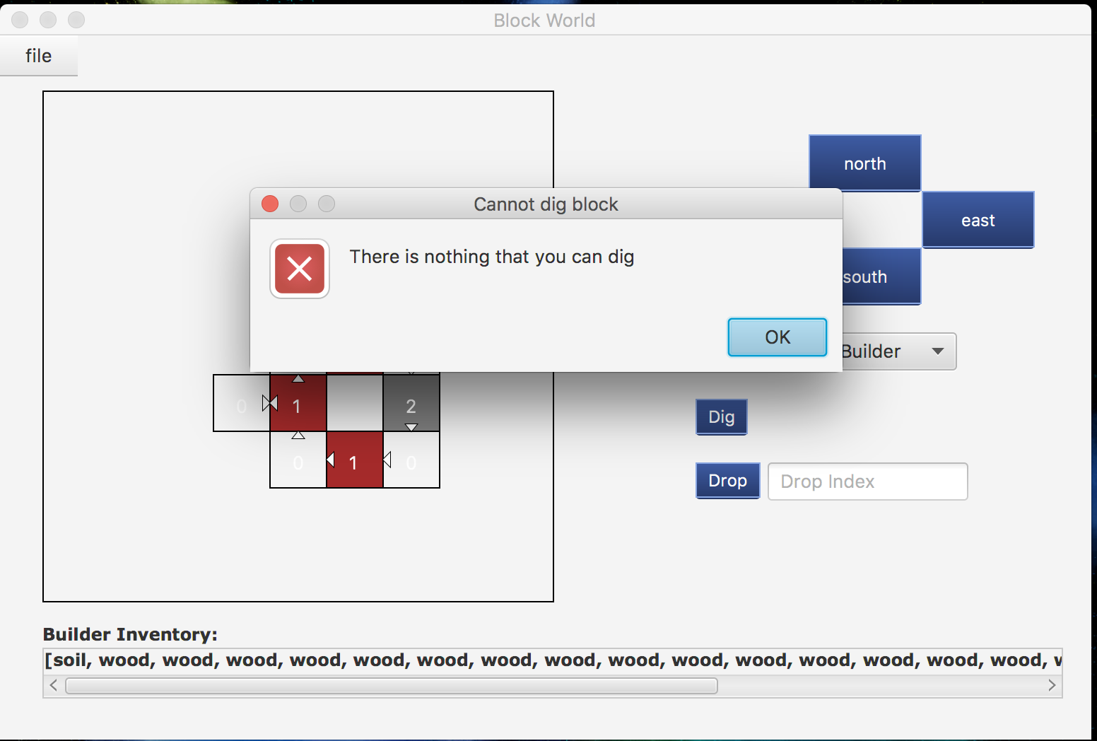

Then, user can also use drop button by typing the drop index. After this action processing, the text field will be clear to wait for user enter new number. The builder inventory and the map will also be changed by this action. (the left one is before its drop, the right one is after drop with the index 4)



If the user enters invalid text, including non-number or the index out of range, the alert box will remind user that this is invalid.

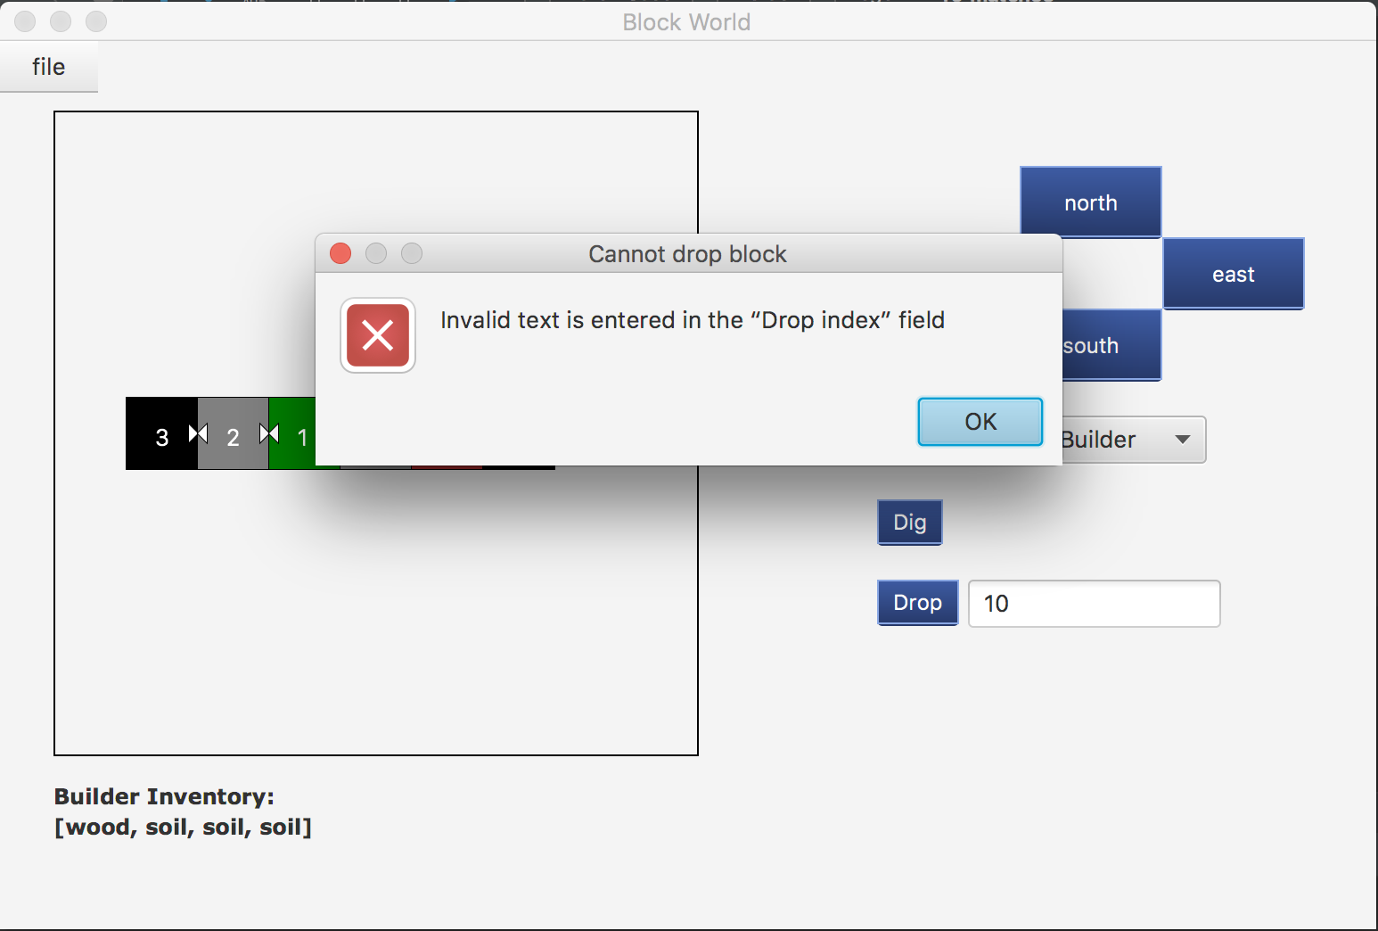

Also if user try to drop block to a tile which contains more than eight blocks, the alert box will show user that the target tile is too high.

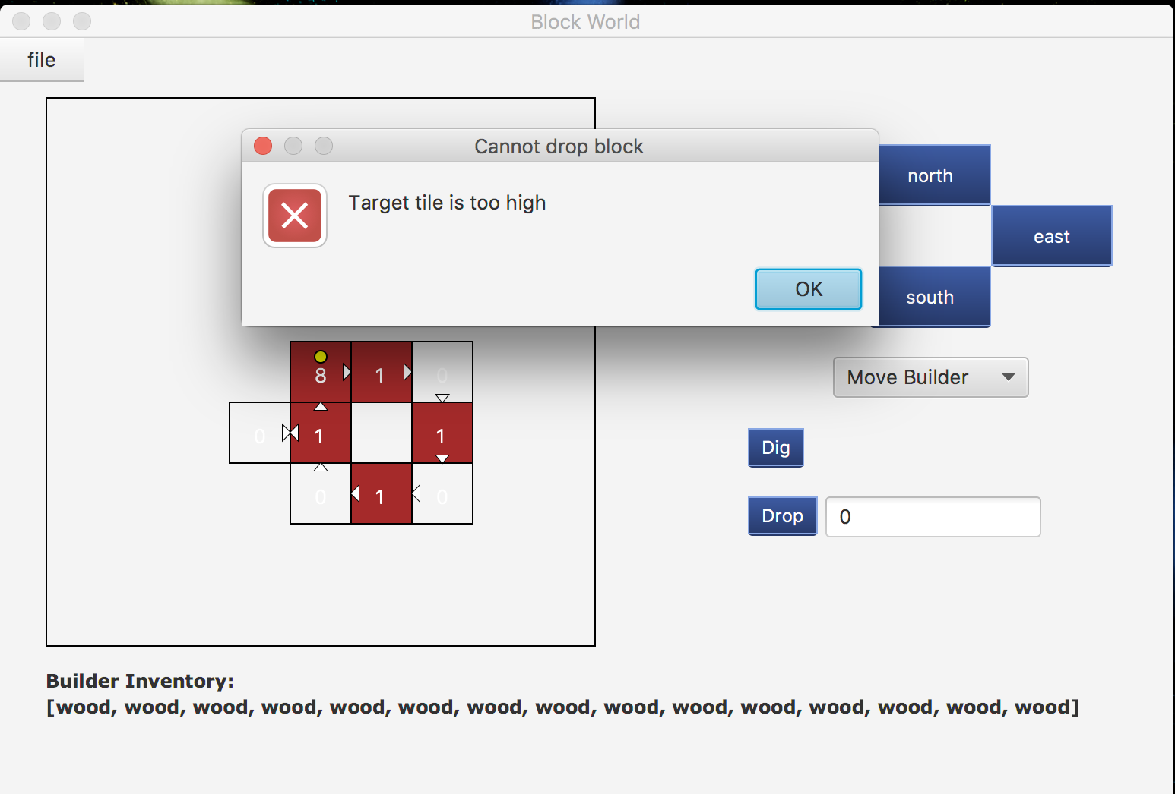

If user wants to save this map, they can click the file menu to save map. Once they saved map, this file will be update, then next time they can back to the same progress. They are allowed to save file in any file they want. Therefore, the file chooser will show again for user to choose the save path. Also, user can still play with this game after save it.

